21BDS0340

Abhinav Dinesh Srivatsa

Programming for Data Science Lab

Digital Assignment – I

**Code**

# BASIC MATH

# sum

300.1 + 200.3 + 300.34

# square root

sqrt(256)

# log and trig methods

log10(100) * cos(pi)

# cumulative sum

cumsum(c(2, 3, 4, 5, 6))

# reverse cumulative sum

cumsum(rev(c(2, 3, 4, 5, 6)))

**Output**

> # BASIC MATH

> # sum

> 300.1 + 200.3 + 300.34

[1] 800.74

>

> # square root

> sqrt(256)

[1] 16

>

> # log and trig methods

> log10(100) * cos(pi)

[1] -2

>

> # cumulative sum

> cumsum(c(2, 3, 4, 5, 6))

[1] 2 5 9 14 20

>

> # reverse cumulative sum

> cumsum(rev(c(2, 3, 4, 5, 6)))

[1] 6 11 15 18 20

**Code**

# ALPHABETS

LETTERS[19]

letters[19]

# last letter

letters[length(letters)]

**Output**

> # ALPHABETS

> LETTERS[19]

[1] "S"

> letters[19]

[1] "s"

>

> # last letter

> letters[length(letters)]

[1] "z"

**Code**

# READING DATASET

Titanic

head(Titanic)

**Output**

> head(Titanic)

, , Age = Child, Survived = No

Sex

Class Male Female

*1st* 0 0

*2nd* 0 0

*3rd* 35 17

Crew 0 0

, , Age = Adult, Survived = No

Sex

Class Male Female

*1st* 118 4

*2nd* 154 13

*3rd* 387 89

Crew 670 3

, , Age = Child, Survived = Yes

Sex

Class Male Female

*1st* 5 1

*2nd* 11 13

*3rd* 13 14

Crew 0 0

, , Age = Adult, Survived = Yes

Sex

Class Male Female

*1st* 57 140

*2nd* 14 80

*3rd* 75 76

Crew 192 20

**Code**

# SIMPLE OBJECTS

x <- 10

y <- 20

z <- x + y

z

**Output**

> # SIMPLE OBJECTS

> x <- 10

> y <- 20

> z <- x + y

> z

[1] 30

**Code**

# VECTORS

myvec <- c(x, y, z)

max(myvec)

min(myvec)

length(myvec)

var(myvec)

rainfall_of_2020 <-c(0.1, 0.6, 0.8, 0.9, 0.1,

0.4, 0.5, 0.6, 0.9, 0.4,

0.4, 0.2)

mean(rainfall_of_2020)

sd(rainfall_of_2020)

cumsum(rainfall_of_2020)

which.max(rainfall_of_2020)

which.min(rainfall_of_2020)

x <- c(1, 2, 5, 9, 11)

y <- c(2, 5, 1, 0, 23)

intersect(x,y)

setdiff(x, y)

setdiff(y, x)

union(x, y)

c(x, y)

**Output**

> # VECTORS

> myvec <- c(x, y, z)

> max(myvec)

[1] 30

> min(myvec)

[1] 10

> length(myvec)

[1] 3

> var(myvec)

[1] 100

> rainfall_of_2020 <-c(0.1, 0.6, 0.8, 0.9, 0.1,

+ 0.4, 0.5, 0.6, 0.9, 0.4,

+ 0.4, 0.2)

> mean(rainfall_of_2020)

[1] 0.4916667

> sd(rainfall_of_2020)

[1] 0.2810963

> cumsum(rainfall_of_2020)

[1] 0.1 0.7 1.5 2.4 2.5 2.9 3.4 4.0 4.9 5.3 5.7 5.9

> which.max(rainfall_of_2020)

[1] 4

> which.min(rainfall_of_2020)

[1] 1

> x <- c(1, 2, 5, 9, 11)

> y <- c(2, 5, 1, 0, 23)

> intersect(x,y)

[1] 1 2 5

> setdiff(x, y)

[1] 9 11

> setdiff(y, x)

[1] 0 23

> union(x, y)

[1] 1 2 5 9 11 0 23

> c(x, y)

[1] 1 2 5 9 11 2 5 1 0 23

**Code**

# MATRICES

m <- matrix(runif(100), ncol = 10)

rowMeans(m)

sd(rowMeans(m))

m <-matrix(runif(100),ncol=10)

cm <-colMeans(m)

cm

hist(cm)

**Output**

> m <- matrix(runif(100), ncol = 10)

> rowMeans(m)

[1] 0.4778937 0.5027204 0.4014370 0.4948259 0.5073903 0.6161583 0.4782482 0.5407035 0.4567420 0.5404460

> sd(rowMeans(m))

[1] 0.05714941

>

> m <-matrix(runif(100),ncol=10)

> cm <-colMeans(m)

> cm

[1] 0.6056659 0.4703680 0.5182126 0.5468369 0.4621683 0.6947287 0.5383646 0.4717294 0.5380697 0.5741593

> hist(cm)

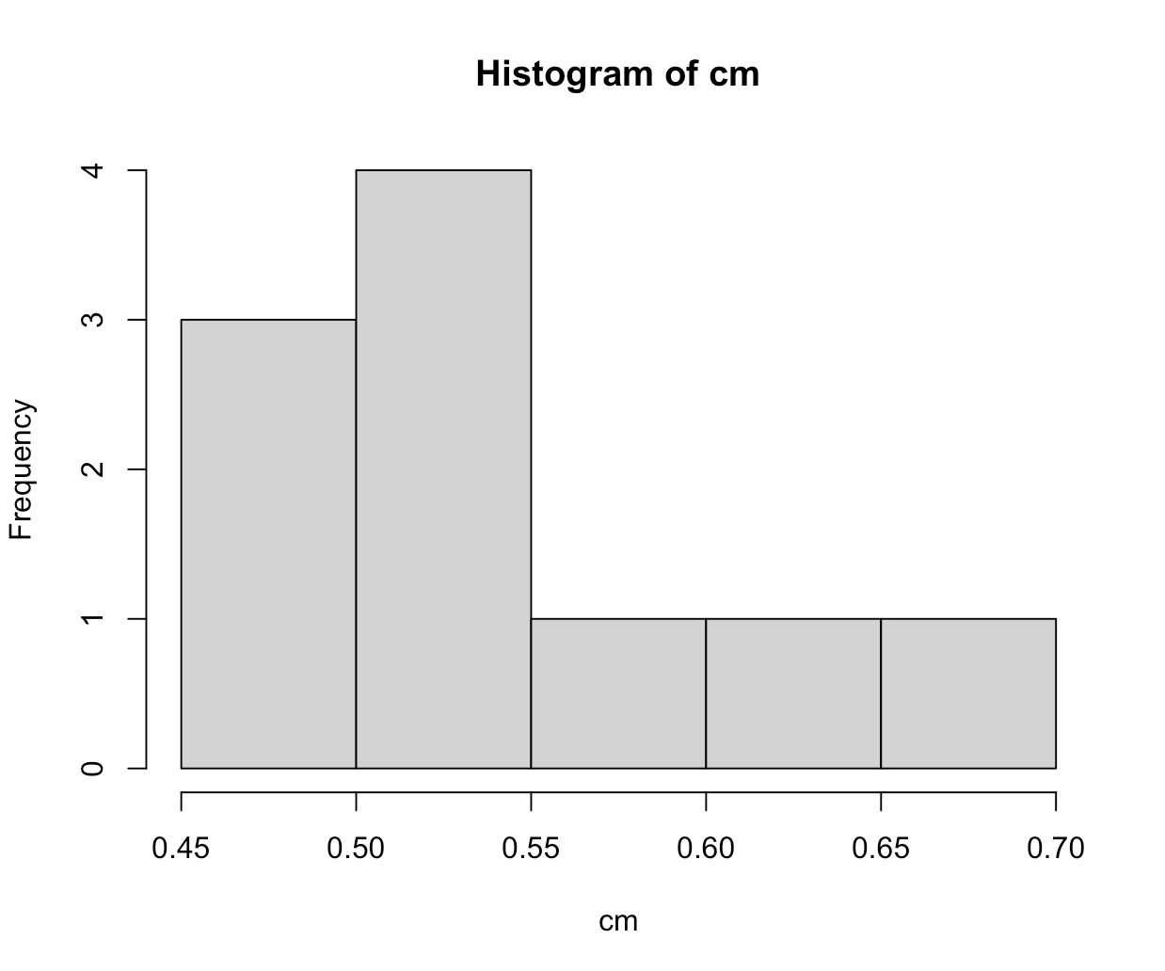

**Code**

# PACKAGES

install.packages("car")

library(car)

# get help of density plot

??densityplot

example(densityPlot)

**Output**

> # PACKAGES

> install.packages("car")

trying URL 'https://cran.rstudio.com/bin/macosx/big-sur-arm64/contrib/4.2/car_3.1-2.tgz'

Content type 'application/x-gzip' length 1711787 bytes (1.6 MB)

==================================================

downloaded 1.6 MB

The downloaded binary packages are in

/var/folders/*2f*/*9fz2wbqj7vlcygt681kl2k0m0000gn*/T//RtmpRS5Xox/downloaded_packages

> library(car)

Loading required package: carData

> # get help of density plot

> ??densityplot

> example(densityPlot)

dnstyP> densityPlot(~ income, show.bw=TRUE, method="kernel", data=Prestige)

Hit <Return> to see next plot:

dnstyP> densityPlot(~ income, show.bw=TRUE, data=Prestige)

Hit <Return> to see next plot:

dnstyP> densityPlot(~ income, from=0, normalize=TRUE, show.bw=TRUE, data=Prestige)

Hit <Return> to see next plot:

dnstyP> densityPlot(income ~ type, data=Prestige)

Hit <Return> to see next plot:

dnstyP> densityPlot(~ income, show.bw=TRUE, method="kernel", data=Prestige)

Hit <Return> to see next plot:

dnstyP> densityPlot(~ income, show.bw=TRUE, data=Prestige)

Hit <Return> to see next plot:

dnstyP> densityPlot(~ income, from=0, normalize=TRUE, show.bw=TRUE, data=Prestige)

Hit <Return> to see next plot:

dnstyP> densityPlot(income ~ type, kernel=depan, data=Prestige)

Hit <Return> to see next plot:

dnstyP> densityPlot(income ~ type, kernel=depan, legend=list(location="top"), data=Prestige)

Hit <Return> to see next plot:

dnstyP> plot(adaptiveKernel(UN$infantMortality, from=0, adjust=0.75), col="magenta")

Hit <Return> to see next plot:

dnstyP> lines(density(na.omit(UN$infantMortality), from=0, adjust=0.75), col="blue")

dnstyP> rug(UN$infantMortality, col="cyan")

dnstyP> legend("topright", col=c("magenta", "blue"), lty=1,

dnstyP+ legend=c("adaptive kernel", "kernel"), inset=0.02)

dnstyP> plot(adaptiveKernel(UN$infantMortality, from=0, adjust=0.75), col="magenta")

Hit <Return> to see next plot:

dnstyP> lines(density(na.omit(UN$infantMortality), from=0, adjust=0.75), col="blue")

dnstyP> rug(UN$infantMortality, col="cyan")

dnstyP> legend("topright", col=c("magenta", "blue"), lty=1,

dnstyP+ legend=c("adaptive kernel", "kernel"), inset=0.02)

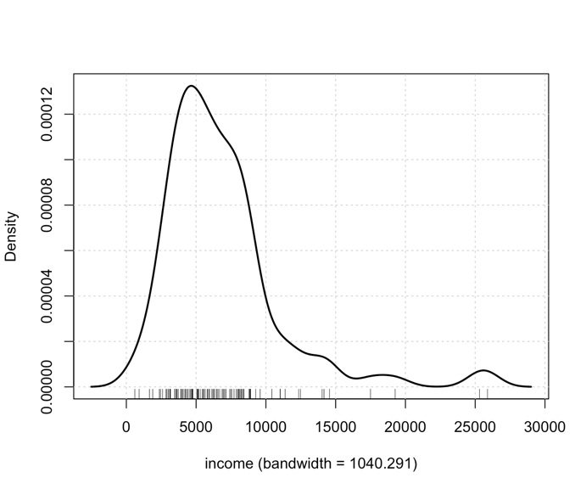

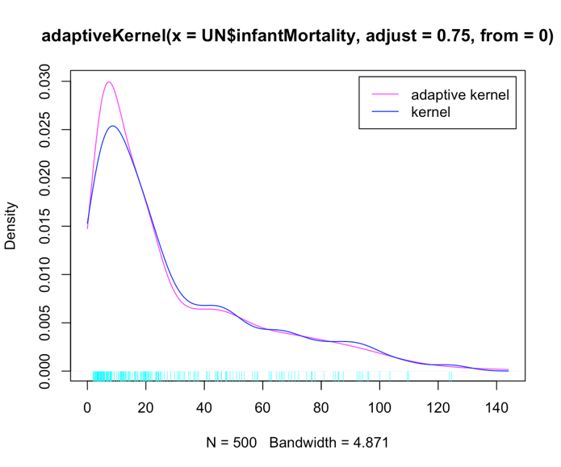

**Code**

# STRINGS

str <- "Hello, Data Visualization!"

print(str)

**Output**

> # STRINGS

> str <- "Hello, Data Visualization!"

> print(str)

[1] "Hello, Data Visualization!"

**Code**

# COMMENTS

# My first R Programming

help() # give help regarding a command, e.g. help(hist)

dim() # gives the number of rows and the number of columns of a matrix, or a data frame

head() # gives the first 6 rows of a large matrix, or data frame

tail() # gives the last 6 rows of a large matrix, or data frame

m[ ,3] # gives the 3rd column of the matrix m

m[2, ] # gives the 2nd row of the matrix m

sum() # get the sum of the values in x by sum(x)

mean() # get the mean of the values in x by mean(x)

median() # get the median of the values in x by median(x)

sd() # get the standard deviation of the values in x

var() # get the variance of the values in x

IQR() # get the IQR of the values in x

summary() # get the summary statistics of a single variable, or of all variables in a data frame

round() # round values in x to 3 decimal places by round(x,3)

sort() # sort the values in x by giving sort(x)

unique() # get the non-duplicate values from a list, e.g. x = c(3,5,7,2,3,5,9,3) and then

unique(x) # gives 3 5 7 2 9

length(x) # gives the length of the vector x, which is 8

hist() # create a histogram of the values in x by hist(x)

stem() # create a stem and leaf plot of the values in x by stem(x)

boxplot() # create a boxplot of the values in x by boxplot(x)

plot() # scatterplot of x vs. y by plot(x,y); for more parameters see help(plot.default)

cor() # gives the linear correlation coefficient

lm() # fit a least squares regression of y (response) on x (predictor) by fit = lm(y~x)

names() # get or set the names of elements in a R object. E.g. names(fit) will give the names of the R object named “fit”, or get or set the names of variables in a data frame.

fit$coef #gives the least squares coefficients from the fit above, i.e. intercept and slope

fit$fitted # gives the fitted values for the regression fitted above

fit$residuals # gives the residuals for the regression fitted above

lines() # add a (regression) line to a plot by lines(x,fit$fitted)

abline() # add a straight line to a scatter plot

points() # add additional points (different plotting character) to a plot by points(x, y2, pch = 5)

scan() # read data for one variable from a text file, e.g. y = scan("ping.dat") Don't forget to change to the appropriate directory first

read.table() # read spreadsheet data (i.e. more than one variable) from a text file

table() # frequency counts of entries, ideally the entries are factors(although it works with integers or even reals)

write() # write the values of a variable y in a file data.txt by write(y,file=”data.txt”)

log() # natural logarithm (i.e. base e)

log10() # logarithm to base 10

seq() # create a sequence of integers from 2 to 11 by increment 3 with seq(2,11,by=3)

rep() # repeat n times the value x, e.g. rep(2,5) gives 2 2 2 2 2

getwd() # get the current working directory.

setwd() # change the directory to. E.g. setwd("c:/Ritchie/RRR.doc")

dir() # list files in the current working directory

search() # searching through reachable datasets and packages

library() # link to a downloaded R package to the current R session. E.g. library(Biostrings) link to the